Form K1: List of Modified Work
A list of modified work is based on an inventory of tasks within each job and an assessment of whether those tasks are within standard restrictions. This information is ideally stored in an electronic format and updated regularly as new job tasks and work procedures emerge.
Each supervisor should have an awareness of each job and essential tasks as they relate to standard restrictions, to support accommodation within the employee’s own job or work group as much as possible.

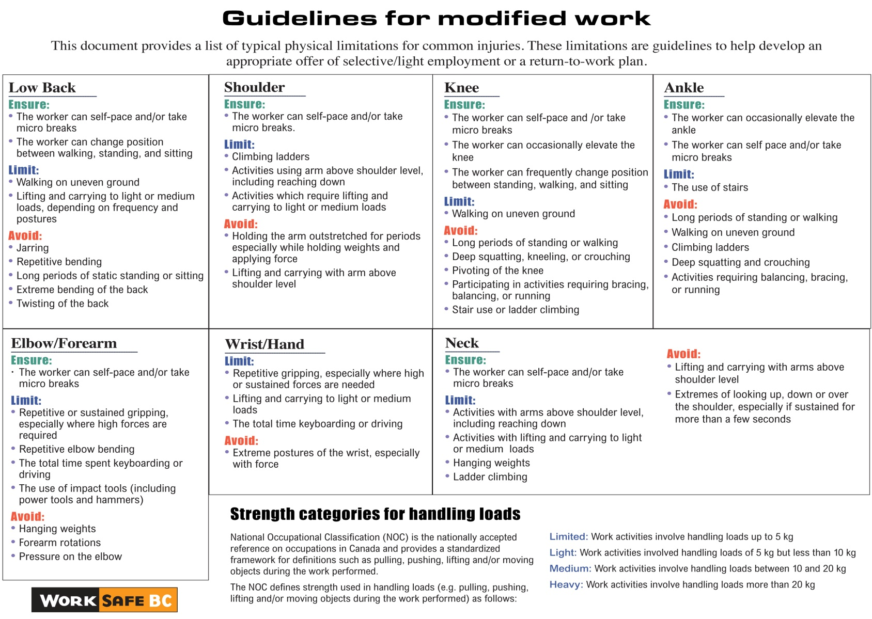

Sample of Modified Work List for Hotels
Please check off the duties that will be part of the modified work offer.
Accounting/Receiving | Modified Work Offer
Filing registration cards
Filing for accounts payable
Alphabetizing packing slips
House accounts — day audits
Administration/Public Relations/Reservation | Modified Work Offer
Press kits
Envelop stuffing
Data entry
Delivering mail by person
Documenting the FHSR’s articles from the newspapers (in COO’s office) into binders
Stuffing welcome cards in envelopes
Filling out amenity forms
Filing and sorting collateral pieces (for example, brochures and sales kits)
Inventory counts (for example, passes)
Filing or reorganizing the filing cabinet (including executive offices)
Bulk mailouts
Dusting and tidying offices, cleaning computer equipment
Backing up hard disks throughout the hotel (after instructions from our systems)
Food and Beverages (Banquets and Outlets) | Modified Work Offer
Polishing cutlery and glasses
Folding napkins
Propping buffets
Light table setting (for example, meetings)
Cleaning and refilling salt and pepper shakers and sugar bowls, and labelling jam jars
Answering telephones, folding menus, changing menu covers
Wrapping presents (seasonal)
Sorting out damaged china
Watering plants and arranging flowers
Light cleaning
Delivering chocolates and fruit baskets
Pre-setting room services tables and trays
Service audits, silent guest audits
Health and safety checklists
Compiling a group email list for email purposes
Confirming reservations
Market analysis — getting menus from other restaurants
Sorting guest comments
Updating log books
Tidying offices
Dropping menu packages with concierges
Statistical analysis — in-house vs. out-of-house guests
Reservation statistics
Log book
Conference Services/Sales | Modified Work Offer
Wedding/sales kits
Filing, including pulling files to be recycled
Mailouts
Purging files
Special events — project list
Convenor shadowing — administrative assistant
Sorting brochures
Delivering mail
Photocopying
Sending faxes
Front Office | Modified Work Offer
Reprogramming telephones
Assisting royal service agents (if there is front-of-house experience)
File keys
General filing for front office and reservations
Combining guest history accounts
Tour F.I.T. filing
Business centre filing
Putting stickers on tour key envelopes
Golf Course | Modified Work Offer
Tags for golf bags for groups
Mailouts for specific events
Marshalling (requires training)
Gift certificate tracking and filing
Making up bag tags for groups
Stuffing brochures
Inventory of scorecards and packet pros
Guest Services | Modified Work Offer
Delivering faxes
Lobby ambassador (if there is front-of-house experience)
Health Club | Modified Work Offer
Managing health club desk (if there is front-of-house experience)
Housekeeping | Modified Work Offer
Quality checks
Clock times
Graveyard assistance — light cleaning
Folding laundry bags
Towel folding (laundry)
Filling upper shelves in pro-host
Dusting hallways
Vacuuming hallways
Collecting dirty robes and tying robes
Stocking employee change rooms
Cleaning outside of guest doors
Folding guest comment cards
Polishing brass door handles
Stocking mobiles
Photocopying for office
Deliveries (small items)
Stripping rooms
Polishing glasses
Cutting the strings off fuzzy bathmats
Putting together guest directories and communication guides
Cutting up rags
Assisting seamstress
Distributing and collecting uniforms
Human Resources | Modified Work Offer
Surveys
Photocopying and building orientation binders
Photocopying and building benefit packages
Building hiring packages
Copying separation packages
Labels for birthday cards
Assisting with communication boards (recruitment and benefits)
Updating MSDS binders
Laminating fire cards
Sorting collateral pieces and other non-sensitive information
Kitchen | Modified Work Offer
Specific to trained cooks only
Assisting chef’s office with paperwork
Polishing
Maintenance | Modified Work Offer
TV/channels
Windows and doors — squeak/open properly
Matching invoices to PO
Monthly safety audits
Security | Modified Work Offer
Battery audit
Graveyard assistance — patrols
Daytime patrols — fire violations
Key audit (requires use of hands)
OFA inventory (requires standing and use of hands)
Pre-con pre-key (requires use of hands)
Incident management and loss analysis
Stewarding | Modified Work Offer
Lemonese plates
Soaking and draining coffee cups
Re-sorting all glassware
Cleaning rack and rolls
Cleaning Queen Mary’s
Washing recycling bins
Sorting cutlery
Polishing chafers
Organizing HR storage
Deep-cleaning banquets dishwashing area (when appropriate)
Organizing chemical room
Organizing silver room
Collecting cutlery and glassware for specific events
Colleague Housing | Modified Work Offer
Cleaning entrances
Wiping down walls and doors
Cleaning lounges and laundry rooms
Recycling (preferably in summer, given potential hazards in winter)
Office work
Salting of walkways (winter)
Tidying and organizing the workshop
Replacing lights in the hallway, laundry rooms and lounges
Replacing broken ceiling tiles and light covers in the hallways and stairwells
Picking up garbage (spring/summer)
Room cleaning
Room inspections before a colleague arrives or leaves
Banquets | Modified Work Offer
Coat checks
Pro host | Modified Work Offer
Sorting amenities
Folding laundry bags
Development | Modified Work Offer
Filing
Assisting with field work (if aligned with employees injuries)
Ground Maintenance | Modified Work Offer
Walkaround and garbage pickup (light garbage)
Flower care (watering, weeding, cultivating and dead heading)
Light maintenance on equipment (if mechanically inclined)
Sweeping patios
Ashtray cleaning and stamping
Ride-on mowing

